SESSION – 2 :-
Q1:- Install Android Studio on your system, open it, and take a screenshot of the welcome screen showing the version number.

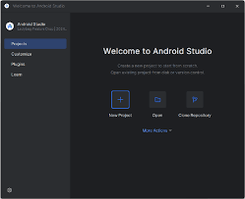

Q2 :- In Android Studio, open the Plugins section and install the Flutter and Dart plugins. Restart the IDE and verify that both plugins are enabled in the settings.
Steps to Install Flutter and Dart Plugins in Android Studio
1. Open Android Studio
Launch Android Studio and wait for it to load.
2. Open Plugins
- Click File → Settings (Windows/Linux)
- Or Android Studio → Settings (macOS)
- Select Plugins from the left sidebar
📸 Take a screenshot of the Plugins screen.
3. Install Flutter Plugin
- Click the Marketplace tab
- Search for Flutter
- Click Install

Q3:-Create a new Android Virtual Device (AVD) in Android Studio with the device name 'Pixel_4_API_30', using any available system image. Start the emulator and share a screenshot of it running.

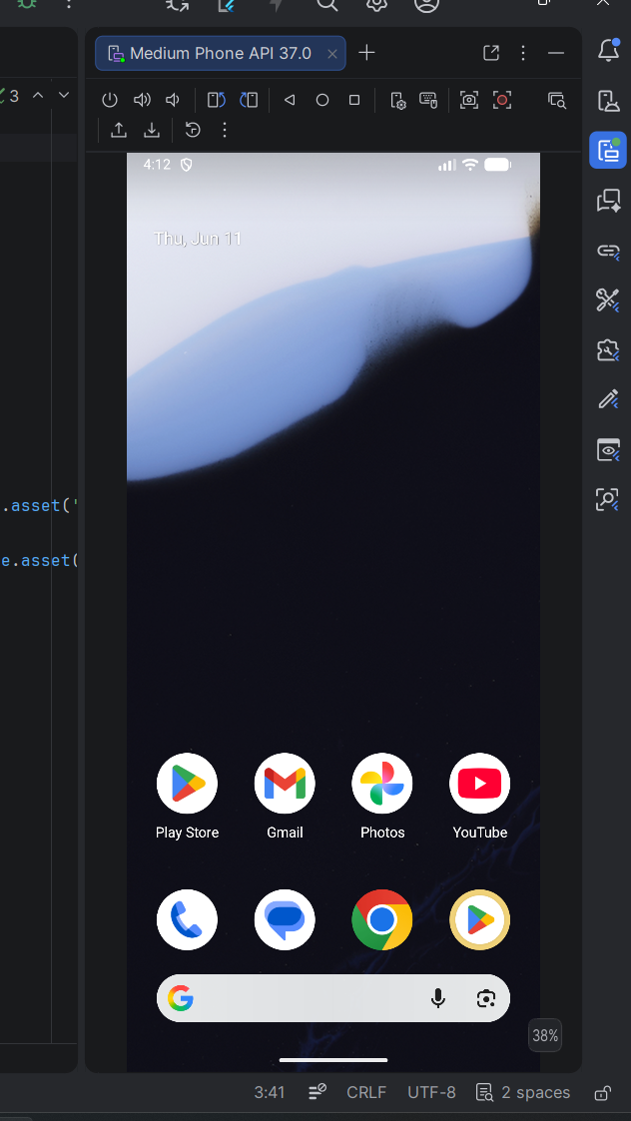
Q4:-Run the default Flutter counter app on your newly created emulator and confirm that the app launches successfully by sharing the emulator screen with the app running.

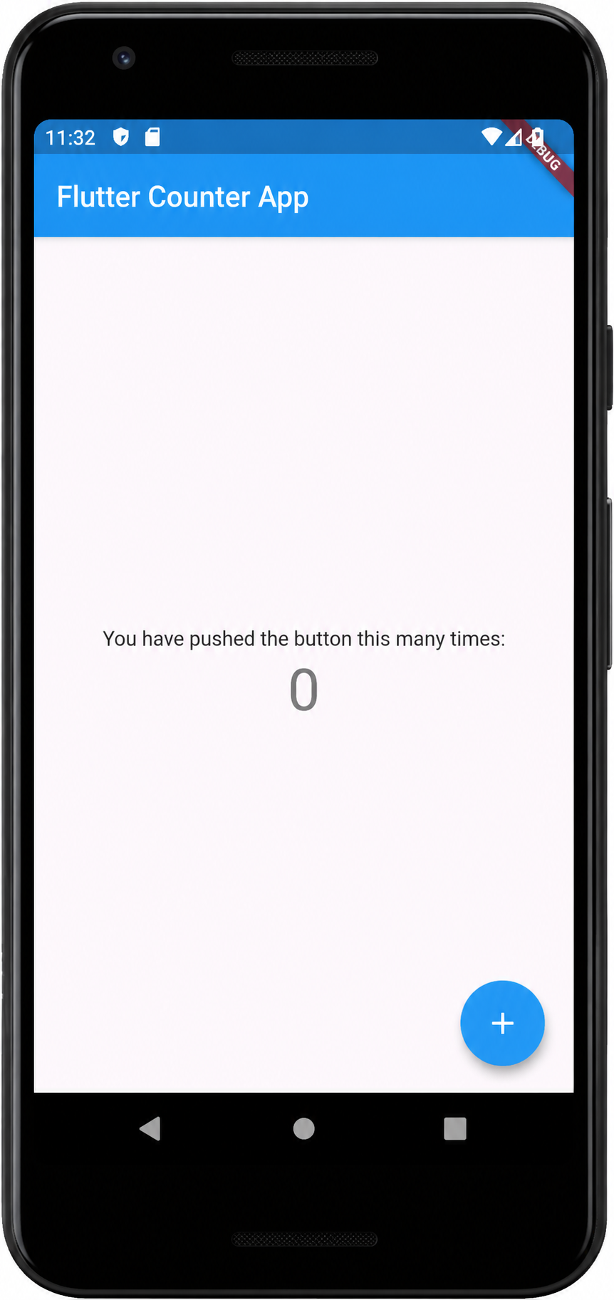
Q5:- List three differences you noticed between running your Flutter app on the emulator versus a real Android device. For each difference, explain how it might affect your development or testing process.<br><br><em><strong>Hint:</strong> Consider speed, device features, and debugging experience.</em>

Difference | Emulator | Real Android Device | Effect on Development / Testing
Performance & Speed | Runs through your computer’s hardware and virtualization, sometimes slower or smoother than actual devices depending on PC specs | Uses real device CPU, GPU, memory, and battery conditions | Performance testing is more reliable on a real device because animations, startup time, scrolling, and responsiveness may behave differently than on the emulator.
Device Features & Hardware Access | Some hardware features are simulated or limited (camera, sensors, GPS, Bluetooth, fingerprint, battery behavior) | Full access to actual hardware components | Features that depend on real hardware should be tested on a physical device to ensure correct behavior and user experience.
Debugging & Development Experience | Easier debugging with quick screenshots, log viewing, hot reload, emulator controls, and reset options | Debugging may take longer due to connecting devices and managing permissions | Emulators speed up UI development and quick testing, while real devices help validate production behavior and catch hardware-specific issues.

